

**AMERICAN INTERNATIONAL UNIVERSITY- BANGLADESH**

**(AIUB)**

**Introduction to Electrical Circuit**

**FALL 2023-2024**

**Section: L, Group: 07**

**LAB REPORT ON**

***Transient Analysis of RC Series and RL series using MULTISIM* Supervised By**

**MD. SHAHARIAR PARVEZ**

|  |  |
| --- | --- |
| **Name** | **ID** |
| **1.MD. Abdullah** | **22-48065-2** |
| **2.Azmir Islam Kafi** | **22-47981-2** |
| **3.Mohammad Ansar Uddin** | **22-47975-2** |
| **4.Chinmoy Guha** | **22-48056-2** |
| **5.Suvra Chakraborty** | **22-48067-2** |

***Abstract:***

Multism serves as a comprehensive electrical circuit simulation tool that enables the creation, validation, and simulation of circuits to determine unknown parameter values and generate graphs. The software includes a library of components and devices that can be employed for constructing, simulating, and illustrating various circuit configurations.

The objective of this exercise was to learn about-

1. Simulation of circuits by using components from the Multisim library
2. Simulation of circuits by writing script files and to analyze obtained graphs and results.

***Circuit diagram:***

**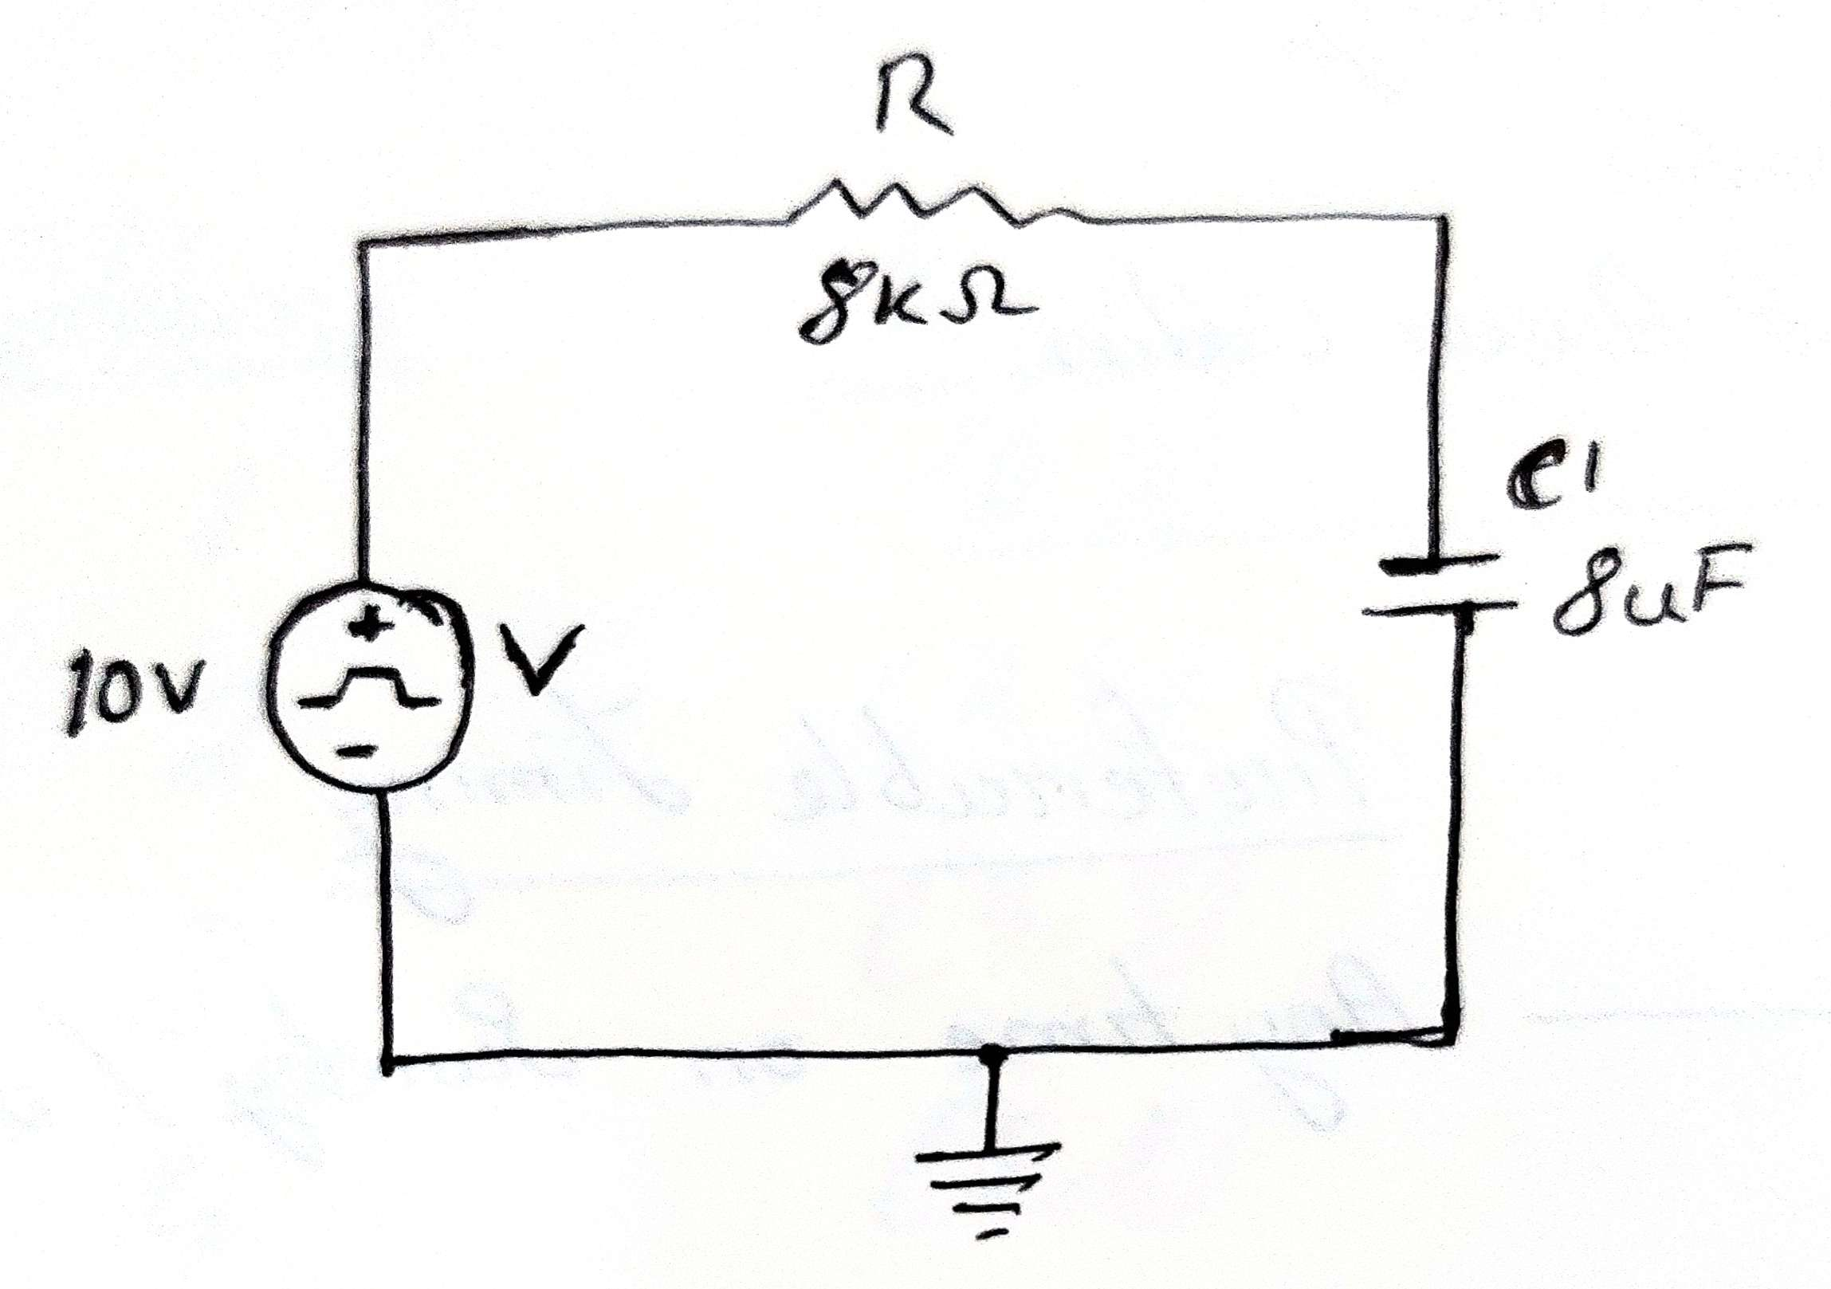 *Figure 1: RC circuit***

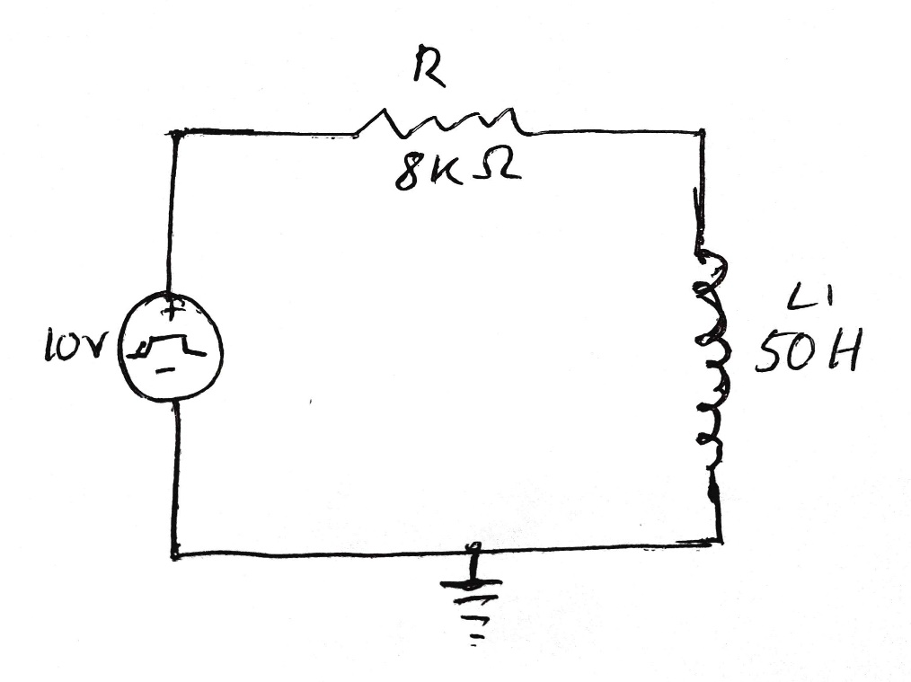

***Figure 2: RL circuit***

**Apparatus:**

1. PC.
2. Multisim Software.

***Experimental Procedure:***

The process began by opening the Multisim software window through the sequence Start → Program → Multisim. Subsequently, the component window was accessed from the menu bar using the path Place → Components. Various components such as a DC source, digital clock, step voltage source, resistor, capacitor (for RC), or an inductor (for RL) were selected from the components menu, along with a ground source. Clock or pulse voltage sources were incorporated through Place → Components → Sources → Signal_Voltage_Sources → Clock_Voltage or Pulse_Voltage. The parameters for the sources, resistors, and capacitors/inductors were appropriately configured. The circuit elements were interconnected using wires and labeled accordingly. Moving to the Analysis and Simulation bar, the setting was changed to Transient through Analysis and Simulation → Transient, with initial conditions set to zero. A suitable end time, ensuring visibility of multiple wave cycles but preventing excessive cycles, was selected. Output variables were chosen through Analysis and Simulation → Output → Add output variable, and additional expressions were inserted if necessary via Analysis and Simulation → Output → Add expression. The simulation was then executed for the designed circuit, and the output was analyzed using the simulation grapher view as instructed

***Result analysis :***

**Table 1:**

For RC series circuit,

|  |  |  |  |
| --- | --- | --- | --- |
| Time (t) | Value Time Constant | % Charged | Vc |
| τ | 64ms | 63% | 6.3 |
| 2τ | 128ms | 86% | 8.6 |
| 3τ | 192ms | 95% | 9.5 |
| 4τ | 256ms | 98% | 9.8 |
| 5τ | 320ms | 99% | 9.9 |

**Table 2:**

For RL series circuit,

|  |  |  |  |
| --- | --- | --- | --- |
| Time (t) | Value Time Constant | % Storage | IL |
| τ | 6.25ms | 63.2% | 0.79uA |
| 2τ | 12.5ms | 86% | 1.08uA |
| 3τ | 18.75ms | 95% | 1.187uA |
| 4τ | 25ms | 98% | 1.227uA |
| 5τ | 31.25ms | 99% | 1.24uA |

***Simulation:  
  
TABLE 1:***

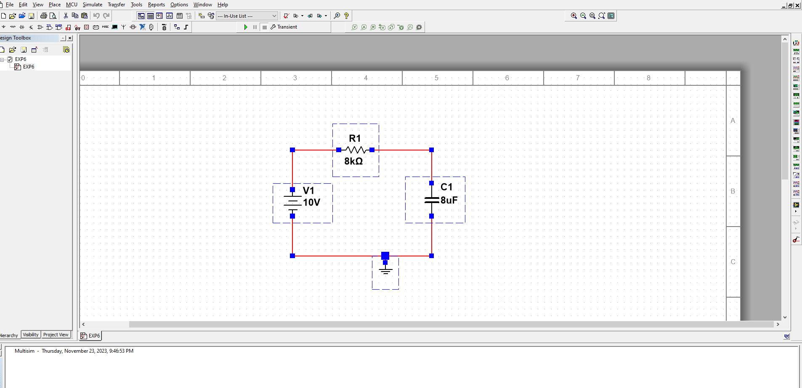

***Figure: RC Circuit.***

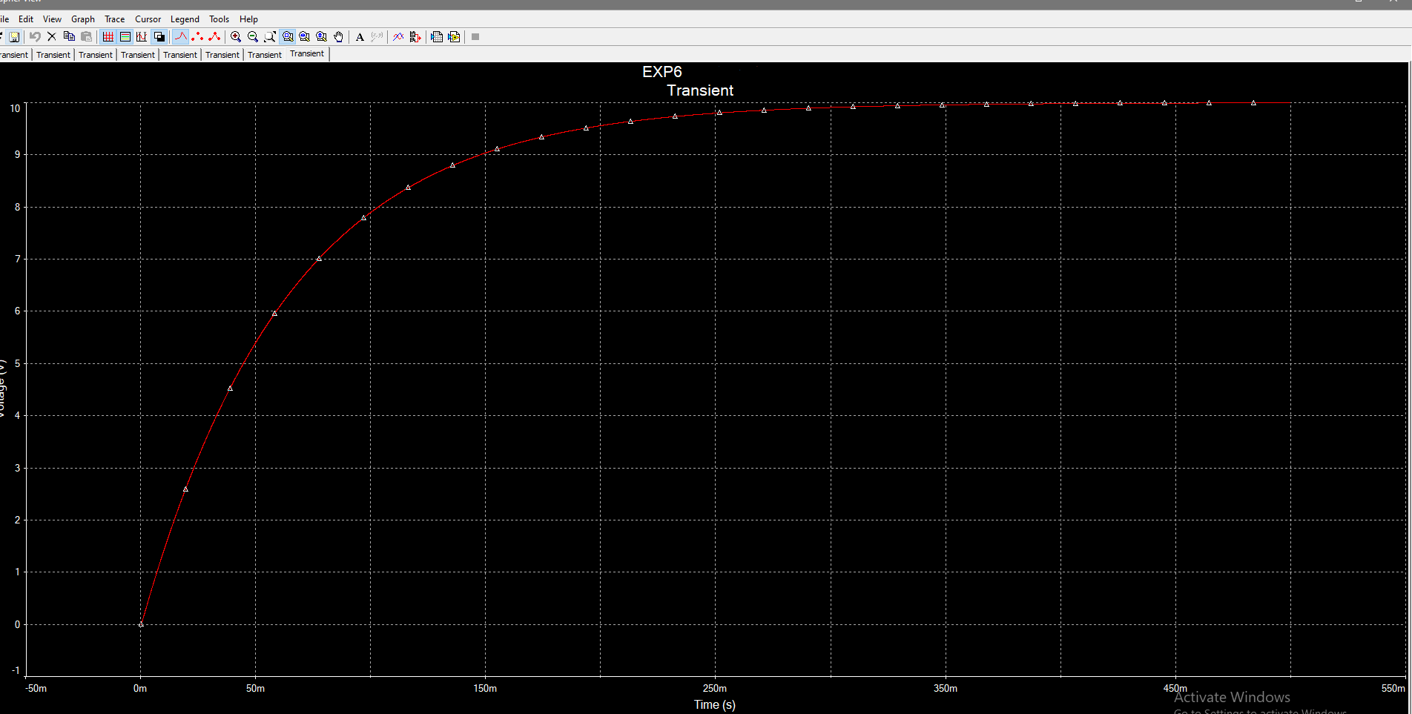

***Figure: RC graph.***

***TABLE 2:***

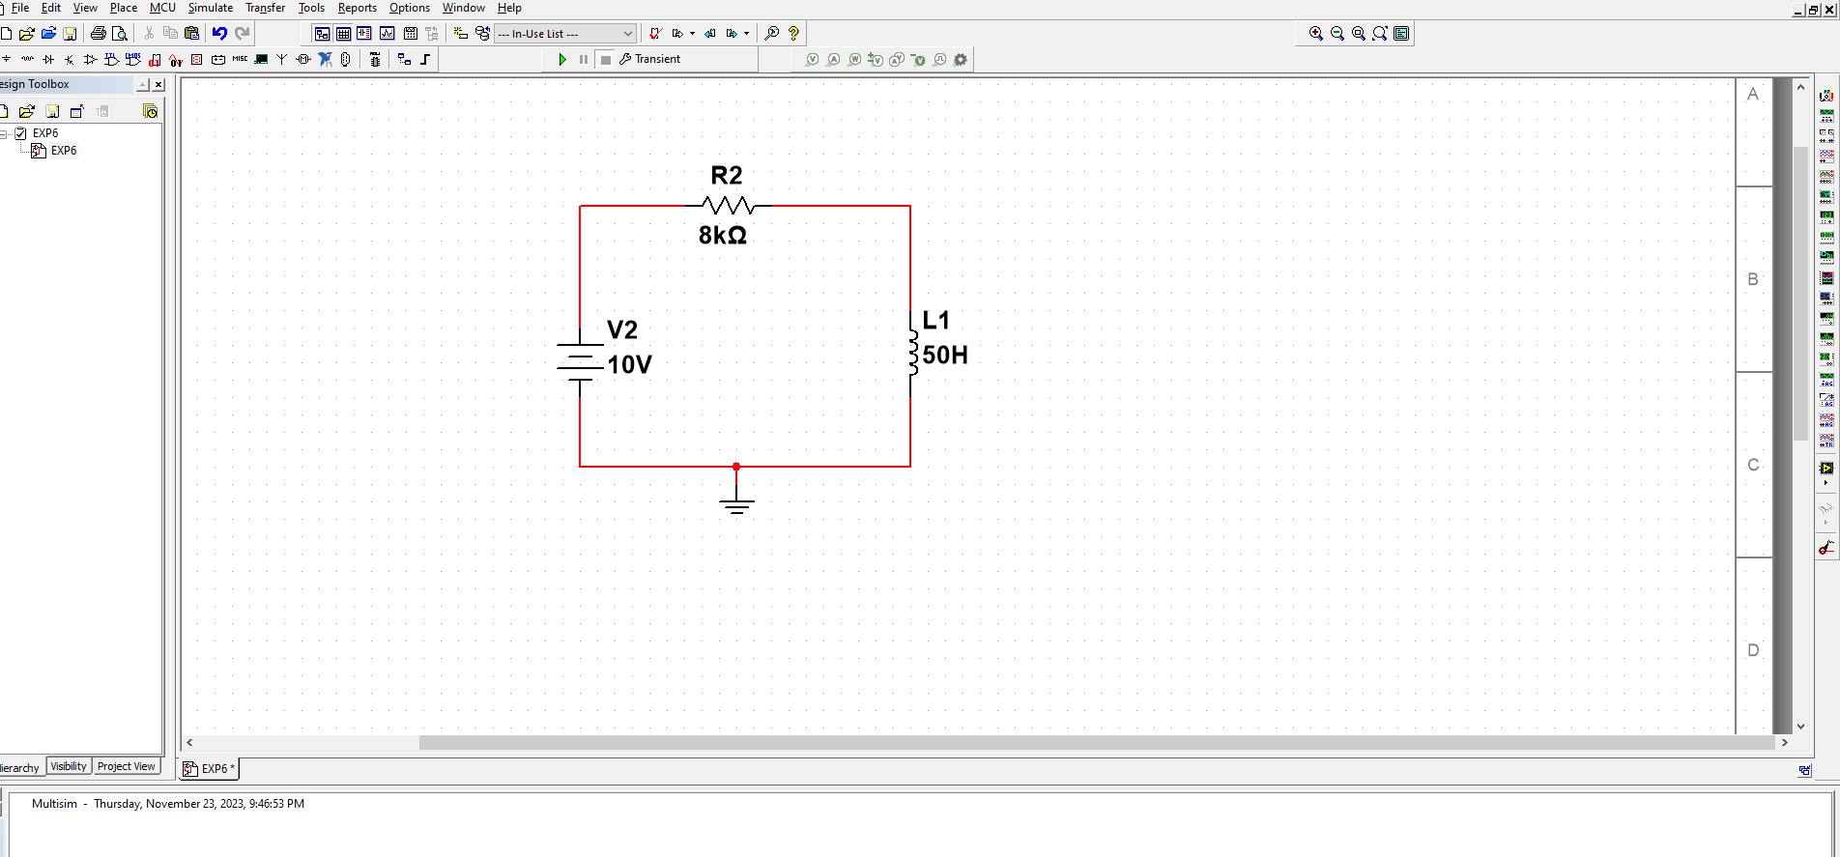

***Figure: RL Circuit.***

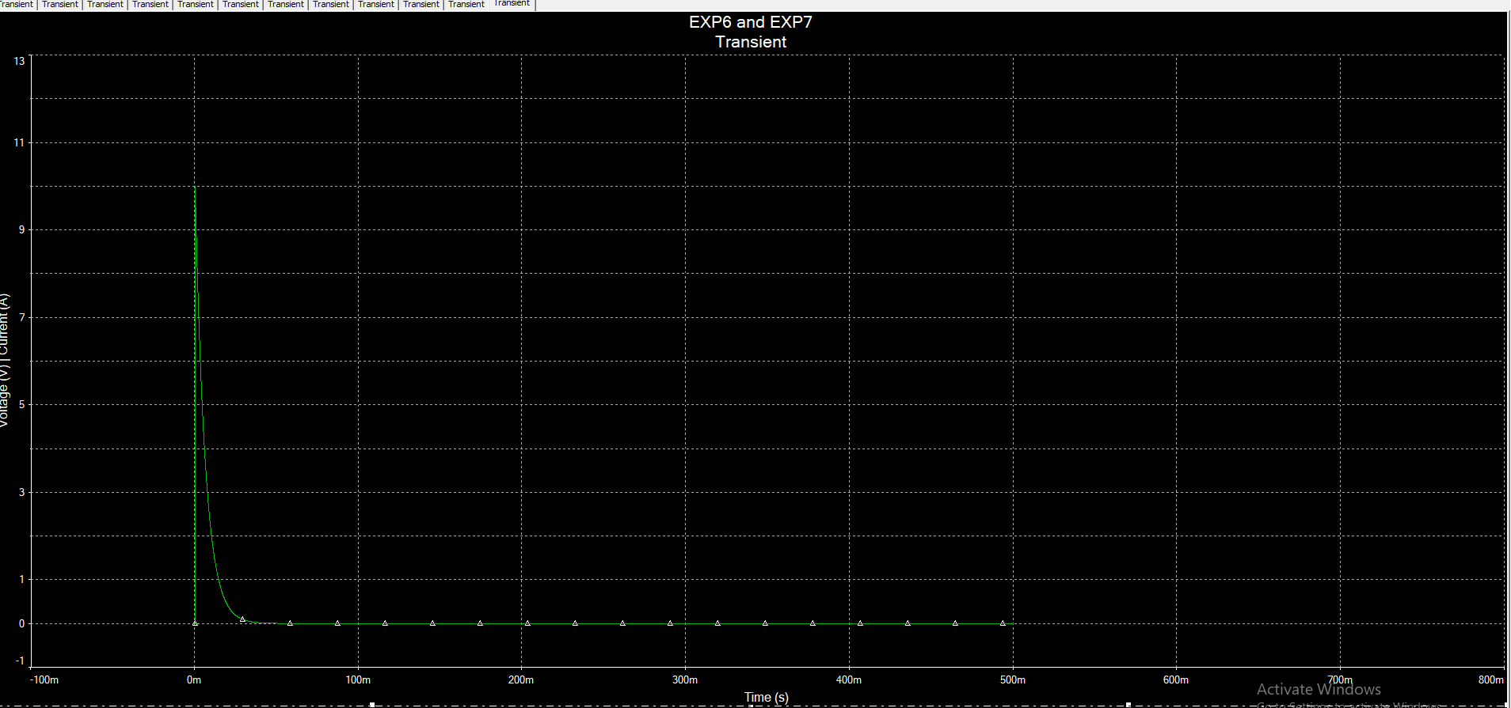

***Figure: RL Graph***

***Calculation:***

For Table 1:

Time Constant = RC = 64ms

1T = 64ms

2T = 128ms

3T = 192ms

4T = 256ms

5T = 320ms

Vc readings were taken from the simulation.

% charged:

1T = 6.3/10 * 100%

2T = 86%

3T = 95%

4T = 98%

5T = 99%

For Table2:

Time Constant = L/R = 6.25ms

1T = 6.25ms

2T = 12.5ms

3T = 18.75ms

4T = 25ms

5T = 31.25ms

iL readings were taken from the simulation.

% charged:

1T = 0.79/1.25 * 100% = 63%

2T = 86%

3T = 95%

4T = 98%

5T = 99%

***Discussion***

The complete experiment was done with Multisim software and the simulation values do match with the calculations that can be done with the formulae.

***Conclusion:***

Transient Analysis of RC Series and RL series using MULTISIM completed successfully.